**Screen Layouts**

The Screen Layouts show the layout for each device that Sweet Karoline Cake’s website could be displayed on. The layouts are the default browser, tablet layout, and smartphone layout. Each of the three layouts will be different due to the size dimensions of the user’s screen. For efficiency, the website should have these to make it easier to navigate the website on each device as well as look professional.

Default Browser Layout: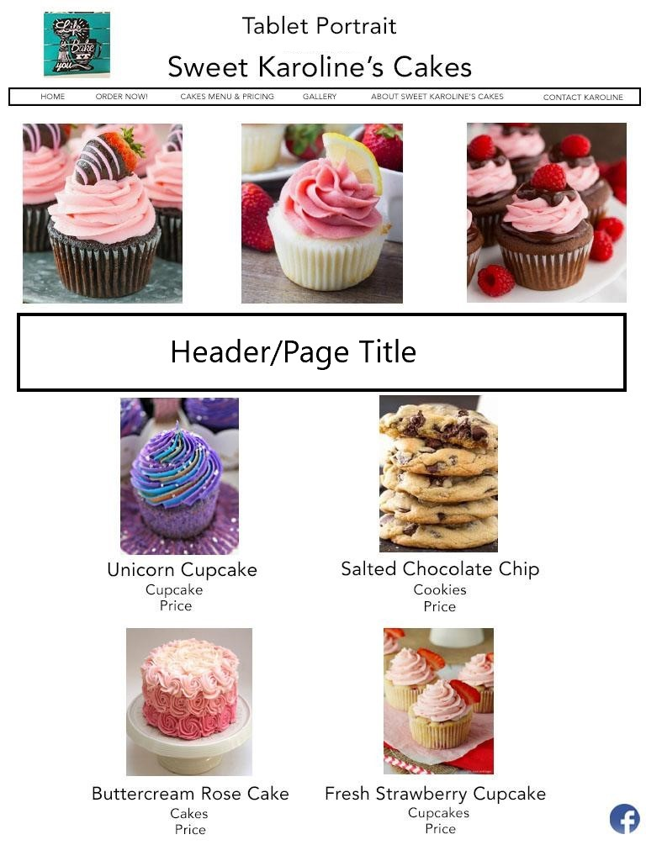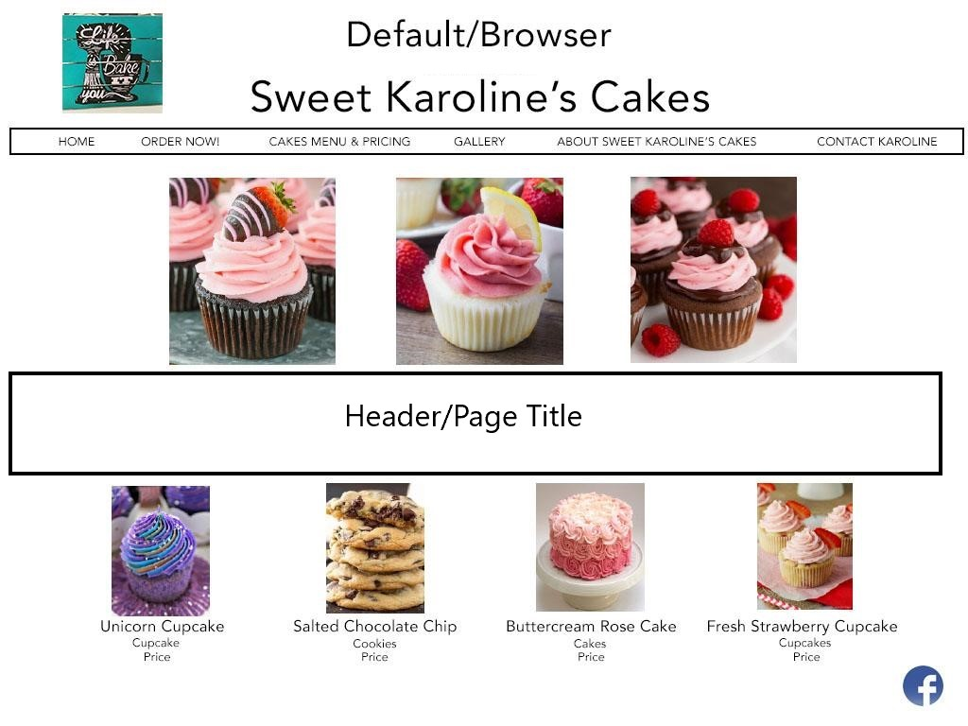

Smartphone Layout:

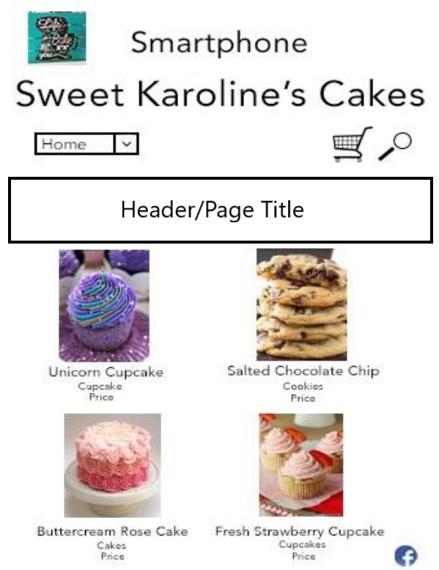

Tablet Layout:

